Inventory CONTROL SYSTEM

Carrefour Inventory Control

[School]

[Course title]

Table of Contents

Inventory control system of Carrefour 2

Carrefour Introduction: 2

Case Study of Inventory control system of Carrefour 3

Scope and Requirements: 4

Functional Requirements: 4

Nonfunctional Requirements: 5

Use Case Diagram: 6

Activity UML Diagrams: 7

Low Level Data Flow Diagrams: 8

Sequence Diagrams: 9

UML Class Diagrams: 10

Pros and Cons of this Inventory Control System: 11

Conclusion: 11

Reference: 13

# Inventory control system of Carrefour

## Carrefour Introduction:

Carrefour is also a French retail company which was revealed in 1959 within the middle of France. Inventor of the French superstore concept in 1963, the Carrefour Group has considerably grown.

Carrefour is one in all the foremost important retailers and one in all the most important supermarket chains in our world and its head quarter exists in France. Carrefour is taken under consideration because Revenue after Wal-Mart, the second largest supermarket company. Carrefour additionally has numerous subsidiaries, especially in Asia, Europe, and geographical regions, which are spread throughout the world.

The company operates extensively in a number of countries such as Chain, UAE, KSA, Brazil, etc. Carrefour Group at domestic level includes the adventure with the hypermarket in Majida-Futtaim that offers the same high-quality services and goods. Carrefour is a worldwide company with many alternatives to the public, for example, clothes, food, and ATM banking as well as to other goods and services that we will cover in the next section of our paper.

Carrefour Group has several methods for optimizing its activities and being a leader in the supermarket sector. The Carrefour Corporation aims to be a favorite supermarket around the world. Thus, there are several outlets around the world with 471 000 staff that retain new buyers and deliver as well as possible. The Carrefour Company also has numerous obligations for its prospective clients; it is responsible for delivering high-quality goods and service, being able to meet its customers and producing what consumers' needs are in the shortest possible period.

## Case Study of Inventory control system of Carrefour

Carrefour's inventory tracking scheme is the system where all the facets of proper management are completed. These elements include knowledge management for the various products, employees, administrators, clients, accounting etc. The Retail Knowledge Management strategy is an effective means of management. The customer may still order and purchase the bought products. The project is focused on the purchase transaction and the carrefour billing. This system is used by four people. System operator, client, and cashier. Main administration. They do various duties in accordance with their responsibilities. Like shops, client management, procurement, distribution, payment management, inventory management, user management and so on. The best managed businesses, client management, purchase management, sales, payment management, product management, user management and carrefour's whole warehouse.

Customer management, purchasing management, distribution administration, payments management and product management. Bills are created, Barcode descriptions are shown, and receipts are printed. Payments are made, customers look at merchandise, add product to their cart. Both users, even clients, need to log into their accounts if they wish to use the device. This account also holds all customer information, which is created with an arbitrary password and a customer name.

Our tasks are to analysis and design the above case study for a wonderful and well-maintained inventory of Carrefour.

## Scope and Requirements:

As Carrefour is a well-known brand world famous for its market strategies and market followship. This inventory control system will be very productive and well managed for the worldwide business of Carrefour. This system will use all over the world wherever Carrefour opens its store. This system will manage all the records of the inventory of Carrefour. All the sales and purchase will be monitored under this system. If this system successful and give result according to the demand and supply of Carrefour we can easily expand it to the other stores of the world, whoever wants to adopt our concept of a very well managed and service-oriented system.

This system can also convert to online system by adding some extra efforts. And when this system will go on the bed of the user/customer, it will create more advancement in the system of supermarkets all over the globe.

Here are some functional and non-functional requirements that will be followed during the designing and implementation of the system.

## Functional Requirements:

* This system should allow a Main Admin to control all the system.
* System will have different modules. Such as Sales, Purchase, Product management, Customer care etc.
* System will produce receipt for the record of customer.
* Anyone who login to the system, she/he must have to go through a strict process of authentication.
* Store User information according to the role of the system.
* Customer account will be made when a customer does any purchase or transition with carrefour.
* System should access to the previous record of the system.
* Every user will have access to a specific module, only an authorized person will allow to use his/her module, except Main Admin.
* Display all the record of shopping to customer.

## Nonfunctional Requirements:

Security:

* This system will be secure for all Viruses and Malwares.
* Any unauthorized will never allow to use this system.

User Interface:

* Blue, White, and Black are the main colors that will show on the screen of user.
* UI should be attractive not boring.

Performance:

* System should give result in maximum 1 to 2 seconds of any query or transactions.

Reliability:

* System should be reliable according to the demand and use.

Operational:

* System should be operatable on any system with minimum Core i5 processor and 4 GB RAM.

Compatible:

* System should be compatible with the upcoming new tech gadgets.

## Use Case Diagram:

* Main User of this inventory handles all other users, stores, and customers.
* System user handles customer, purchases, sales, and products.
* Customers view the products, add to cart, and do payments.
* Cashiers create bills, generate receipt and view barcode details.

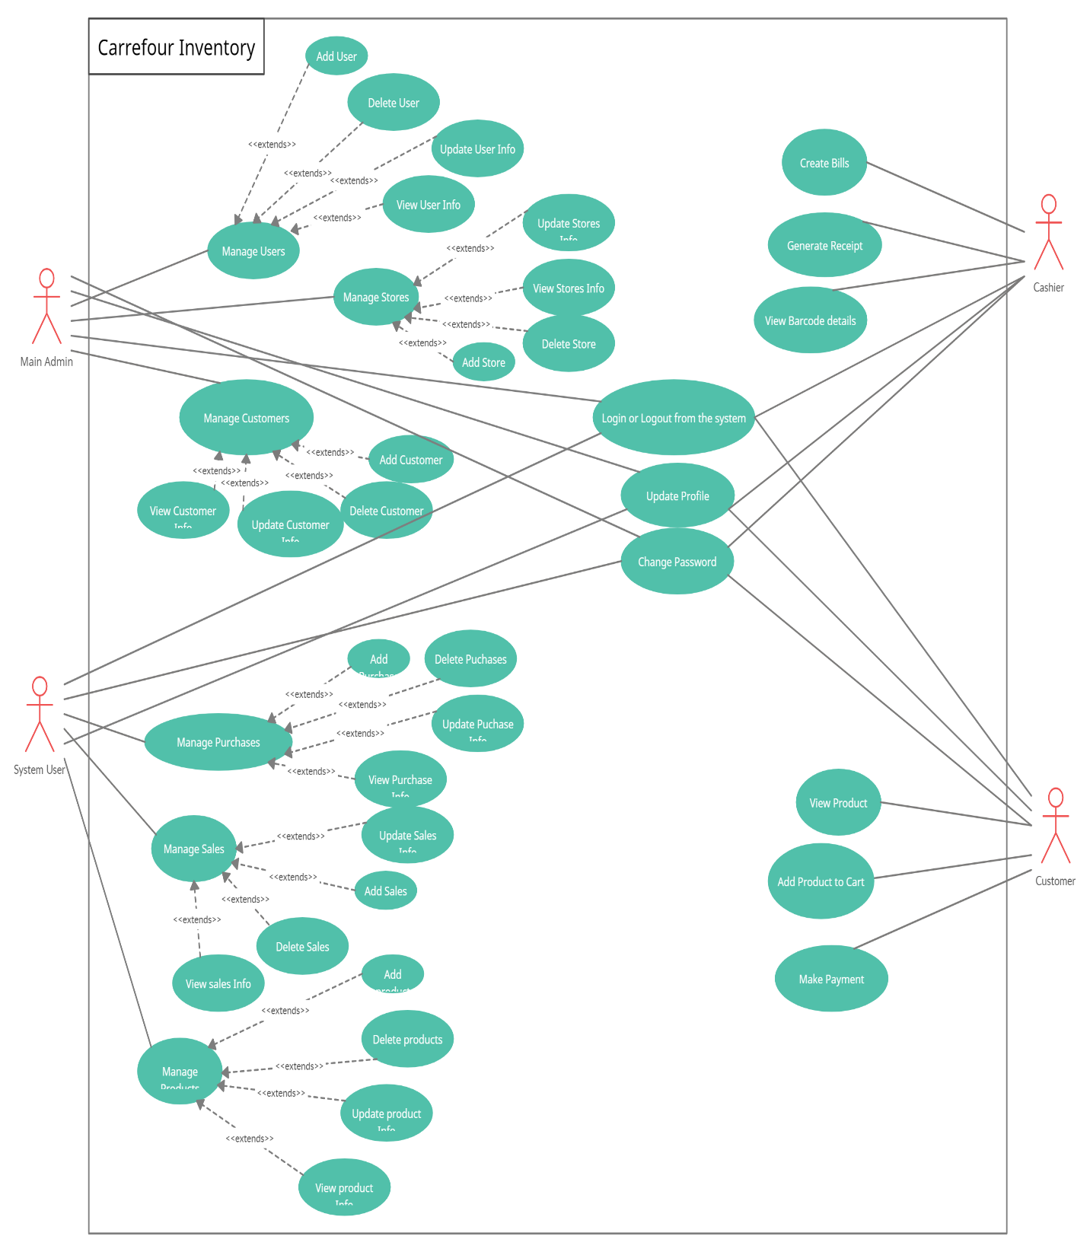

## Activity UML Diagrams:

Users’ login to system by providing their login details. System checks the authority of the user according to their roles. Then a process of authentication occurs, this process will decide the job/tasks that can an authorized user according to its role. After that, every user performs tasks as per their modules. And then logout from the system.

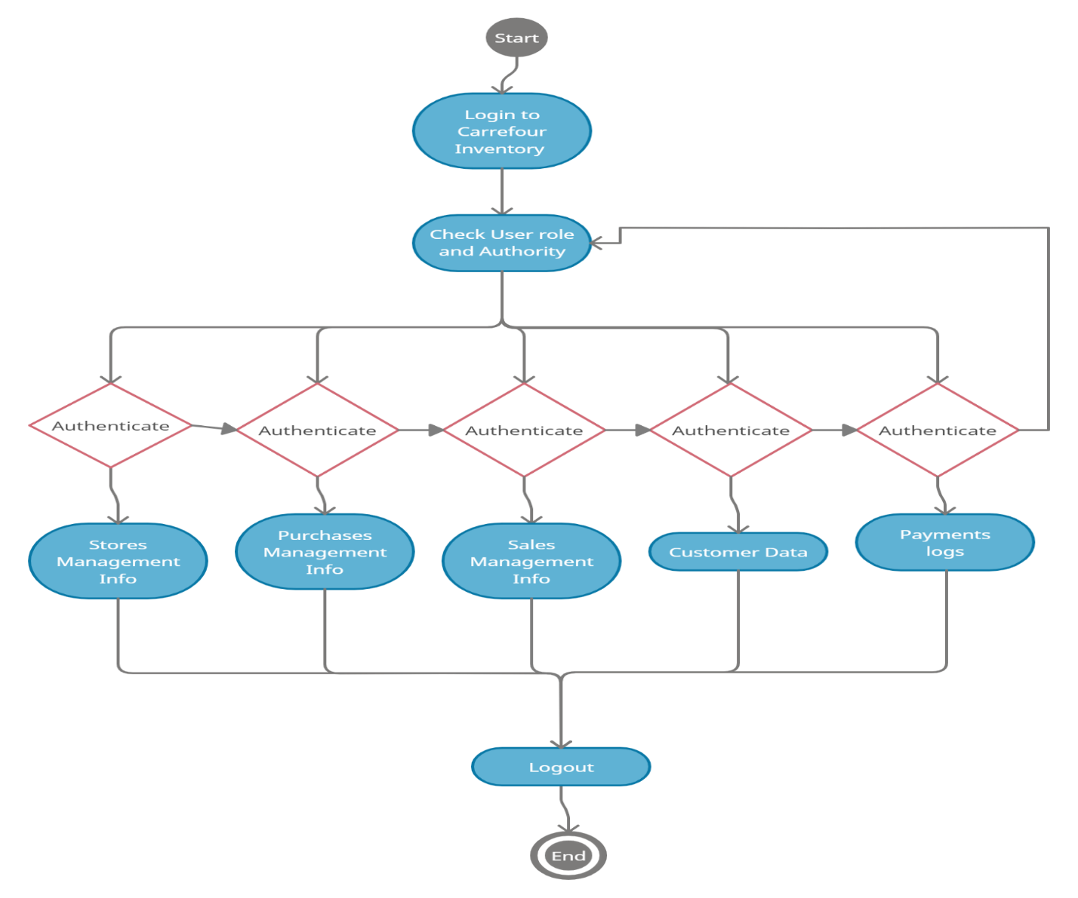

## Low Level Data Flow Diagrams:

Users’ login to framework by giving their login subtle elements. Framework checks the specialist of the client agreeing to their parts. At that point a handle of verification happens, this prepare will choose the job/tasks that can an authorized client concurring to its part. After that, each client performs assignments as per their modules. And after that logout from the framework.

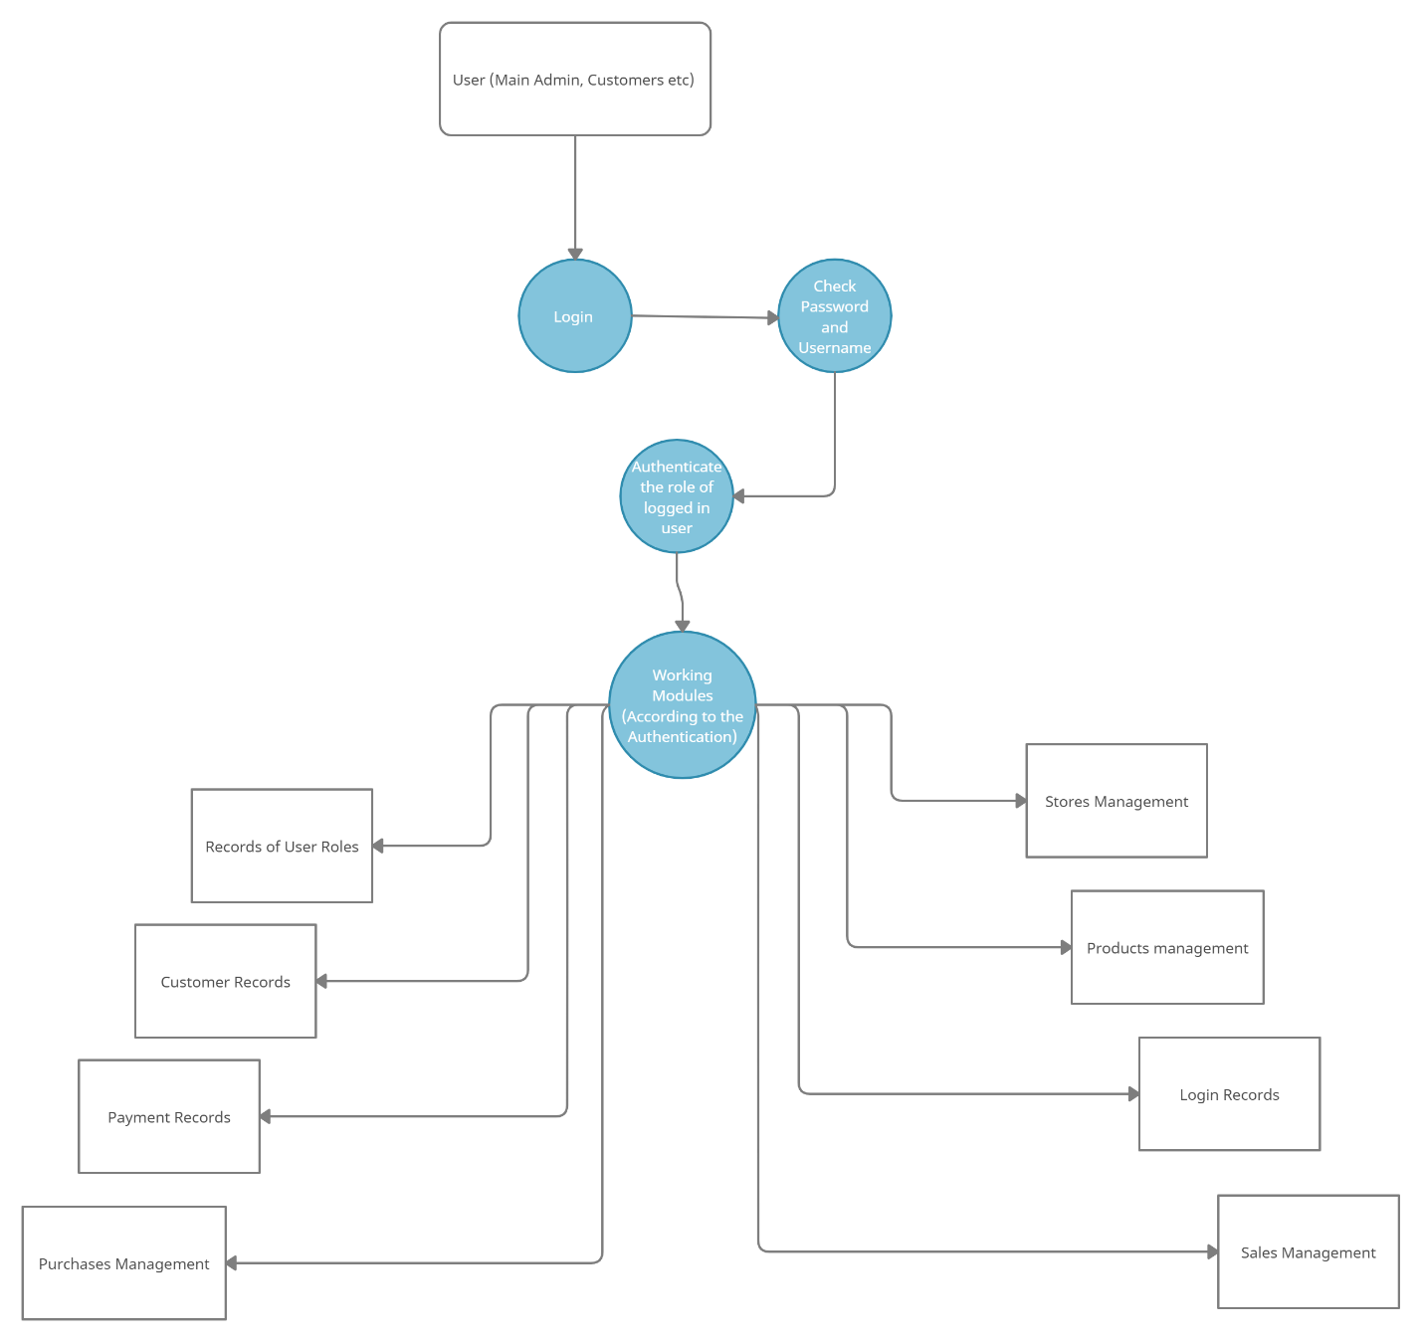

## Sequence Diagrams:

This diagram shows the complete process of using the system, from the login to authentication to add, delete, update, and view the records, at the end logout from the system.

Users’ login to system by providing their login details. System checks the authority of the user according to their roles. Then a process of authentication occurs, this process will decide the job/tasks that can an authorized user according to its role. After that, every user performs tasks as per their modules. And then logout from the system.

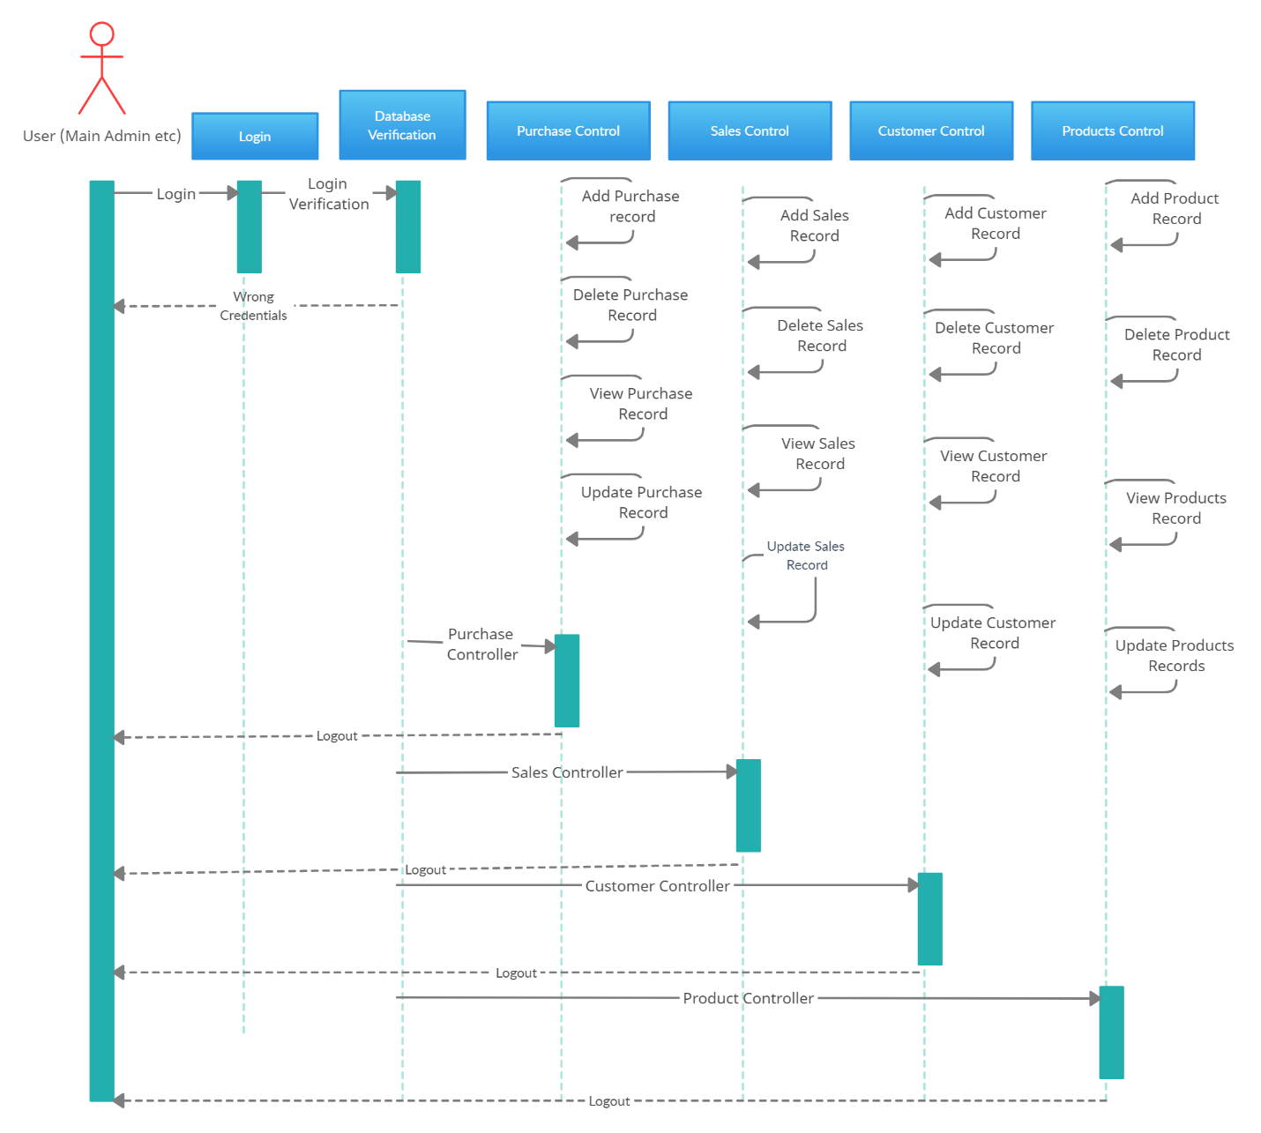

## UML Class Diagrams:

In this Class diagrams we have different classes with their attributes and methods through which all the classes will communicate with one another. Every module of the system has a different class, all of the management modules classes are in aggregation relation with the authorized class.

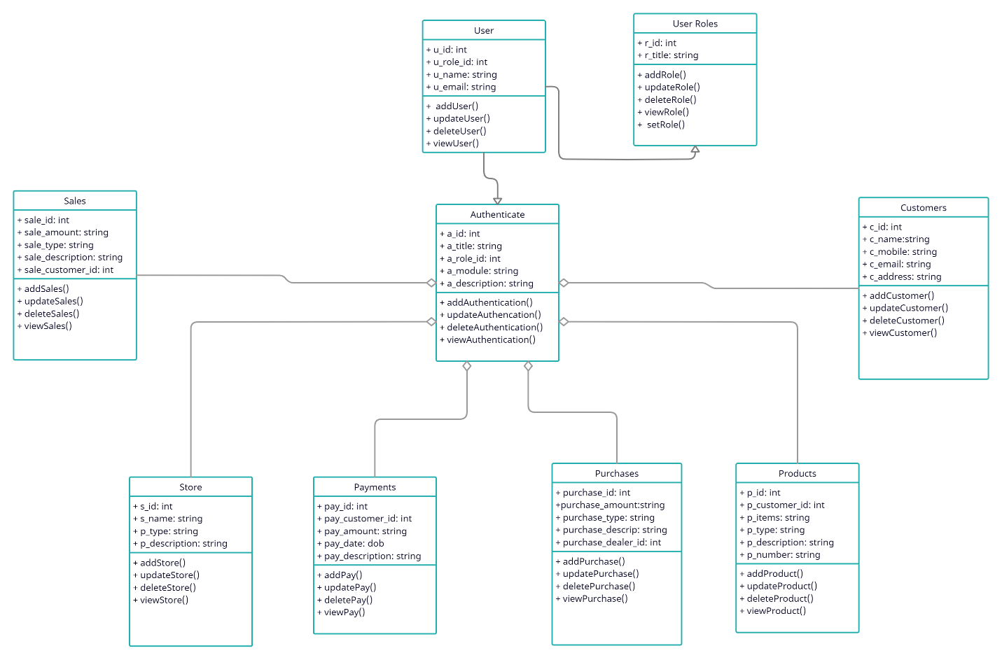

## Pros and Cons of this Inventory Control System:

Pros:

* All the records of carrefour will be well managed and organized.
* This system will reduce the paperwork.
* The business speed will be doubled after the implementation of this proposed system.
* Customer will be satisfied with the quick service.
* Good UI will increase the interest of the workers.

Cons:

* Handling user data in the database.
* There should be a system of undo the transactions at any point of the process.
* Payment methods can be more secure and reliable, such as credit cards etc.

## Conclusion:

To conclude the inventory control of carrefour we can say that in the current scenarios this system will be very helpful in the day-by-day demand and supply of the store. As Carrefour is a well-known brand world famous for its market strategies and market followship. This inventory control system will be very productive and well managed for the worldwide business of Carrefour. This system will use all over the world wherever Carrefour opens its store. This system will manage all the records of the inventory of Carrefour. This project is predicated on the sales transaction and billing of things in carrefour. This system is used by four people. System user, client and cashier Key administrative. They execute various duties in accordance with their responsibilities. Like shops, client management, procurement, distribution, payment management, inventory management, user management, etc. management. The best managed stores, client management, buy management, distribution, payments management, product management, users management and complete carrefour inventory. Customer management, procurement, revenue management, billing administration, inventory management. Cashier creates bills, view barcode details and print receipt. Customers view products, add product to cart and make payments. All the users, except customer, whenever want to use the system they need to login to their accounts. Customer account also created with a random password and name of the customers; this account contains all the shopping details of customer. All the sales and purchase will be monitored under this system. If this system successful and give result according to the demand and supply of Carrefour we can easily expand it to the other stores of the world, whoever wants to adopt our concept of a very well managed and service-oriented system.

## Reference:

Glinz, M., 2007, October. On non-functional requirements. In *15th IEEE International Requirements Engineering Conference (RE 2007)* (pp. 21-26). IEEE.

SANDYBAYEV, A., HOW CARREFOUR REVOLUTIONIZING SUPPLY CHAIN MANAGEMENT: CASE FROM THE UNITED ARAB EMIRATES. *Uluslararası Afro-Avrasya Araştırmaları Dergisi*, *4*(7), pp.210-220.

Bono, F. and Gutiérrez, E., 2011. A network-based analysis of the impact of structural damage on urban accessibility following a disaster: the case of the seismically damaged Port Au Prince and Carrefour urban road networks. *Journal of Transport Geography*, *19*(6), pp.1443-1455.

Herchi, H. and Abdessalem, W.B., 2012. From user requirements to UML class diagram. *arXiv preprint arXiv:1211.0713*.

Evans, A.S., 1998, October. Reasoning with UML class diagrams. In *Proceedings. 2nd IEEE Workshop on Industrial Strength Formal Specification Techniques* (pp. 102-113). IEEE.

More, P. and Phalnikar, R., 2012. Generating UML diagrams from natural language specifications. *International Journal of Applied Information Systems*, *1*(8), pp.19-23.

Saldhana, J. and Shatz, S.M., 2000, July. Uml diagrams to object petri net models: An approach for modeling and analysis. In *International Conference on Software Engineering and Knowledge Engineering* (pp. 103-110).

Kohler, H.J., Nickel, U., Niere, J. and Zundorf, A., 2000, June. Integrating UML diagrams for production control systems. In *Proceedings of the 2000 International Conference on Software Engineering. ICSE 2000 the New Millennium* (pp. 241-251). IEEE.

Chung, L. and do Prado Leite, J.C.S., 2009. On non-functional requirements in software engineering. In *Conceptual modeling: Foundations and applications* (pp. 363-379). Springer, Berlin, Heidelberg.

Lethbridge, T.C. and Laganiere, R., 2005. *Object-oriented software engineering* (Vol. 11). New York: McGraw-Hill.

Bruegge, B. and Dutoit, A.H., 2009. Object-‐Oriented Software Engineering. Using UML, Patterns, and Java. *Learning*, *5*(6), p.7.